|  |  |
| --- | --- |
|  | METHODIST |
| **Estd:2008** | COLLEGE OF ENGINEERING AND TECHNOLOGY |

(Affiliated to Osmania University & Approved by AICTE, New Delhi)



**LABORATORY MANUAL**

**DESIGN AND ANALYSIS OF ALGORITHMS**

BE VI Semester (AICTE Model Curriculum): 2020-21

|  |  |
| --- | --- |
| **NAME: ___________________________________________________________________** | |
| **ROLL NO:__________________________________________________________________** | |
| **BRANCH:__________________** | **SEM:______________________________________** |

**DEPARTMENT OF COMPUTER SCIENCE & ENGINEERNG**

***Empower youth- Architects of Future World***

|  |  |
| --- | --- |
|  | METHODIST |
| COLLEGE OF ENGINEERING AND TECHNOLOGY |
| **Estd:2008** |

**VISION**

To produce ethical, socially conscious and innovative professionals who would contribute to sustainable technological development of the society.

**MISSION**

To impart quality engineering education with latest technological developments and interdisciplinary skills to make students succeed in professional practice.

To encourage research culture among faculty and students by establishing state of art laboratories and exposing them to modern industrial and organizational practices.

To inculcate humane qualities like environmental consciousness, leadership, social values, professional ethics and engage in independent and lifelong learning for sustainable contribution to the society.

|  |  |
| --- | --- |
|  | METHODIST |
| **Estd:2008** | COLLEGE OF ENGINEERING AND TECHNOLOGY |

DEPARTMENT

**OF**

**COMPUTER SCIENCE AND ENGINEERING**

**LABORATORY MANUAL**

**DESIGN AND ANALYSIS OF ALGORITHMS**

**Prepared By**

Dr. E. Shailaja, Assoc. Professor.

Mr. P. V. Ramanaiah Assistant Professor.

|  |  |
| --- | --- |
|  | METHODIST |
| COLLEGE OF ENGINEERING AND TECHNOLOGY |
| **Estd:2008** |

**DEPARTMENT OF COMPUTER SCIENCE AND ENGINEERING**

**VISION & MISSION**

**VISION**

To become a leader in providing Computer Science & Engineering education with emphasis on knowledge and innovation.

**MISSION**

* To offer flexible programs of study with collaborations to suit industry needs.
* To provide quality education and training through novel pedagogical practices.
* To expedite high performance of excellence in teaching, research and innovations.
* To impart moral, ethical values and education with social responsibility.

|  |  |
| --- | --- |
|  | METHODIST |
| COLLEGE OF ENGINEERING AND TECHNOLOGY |
| **Estd:2008** |

**DEPARTMENT OF COMPUTER SCIENCE AND ENGINEERING**

# PROGRAM EDUCATIONAL AIMS

**After 3-5 years of graduation, the graduates will be able to**

**PEO1:** Apply technical concepts, Analyze, Synthesize data to Design and create novel products and solutions for the real life problems.

**PEO2:** Apply the knowledge of Computer Science Engineering to pursue higher education with due consideration to environment and society.

**PEO3:** Promote collaborative learning and spirit of team work through multidisciplinary projects

**PEO4:** Engage in life-long learning and develop entrepreneurial skills.

|  |  |
| --- | --- |
|  | METHODIST |
| COLLEGE OF ENGINEERING AND TECHNOLOGY |
| **Estd:2008** |

**DEPARTMENT OF COMPUTER SCIENCE AND ENGINEERING**

# PROGRAM OUTCOMES

### Engineering graduates will be able to:

**PO1: Engineering knowledge:** Apply the knowledge of mathematics, science, engineering fundamentals, and an engineering specialization to the solution of complex engineering problems.

**PO2: Problem analysis:** Identify, formulate, review research literature, and analyze complex engineering problems reaching substantiated conclusions using first principles of mathematics, natural sciences, and engineering sciences.

**PO3: Design/development of solutions:** Design solutions for complex engineering problems and design system components or processes that meet the specified needs with appropriate consideration for the public health and safety, and the cultural, societal, and environmental considerations.

**PO4: Conduct investigations of complex problems:** Use research-based knowledge and research methods including design of experiments, analysis and interpretation of data, and synthesis of the information to provide valid conclusions.

**PO5: Modern tool usage:** Create, select, and apply appropriate techniques, resources, and modern engineering and IT tools including prediction and modelling to complex engineering activities with an understanding of the limitations.

**PO6: The engineer and society:** Apply reasoning informed by the contextual knowledge to assess societal, health, safety, legal and cultural issues and the consequent responsibilities relevant to the professional engineering practice.

**PO7: Environment and sustainability:** Understand the impact of the professional engineering solutions in societal and environmental contexts, and demonstrate the knowledge of, and need for sustainable development.

**PO8: Ethics:** Apply ethical principles and commit to professional ethics and responsibilities and norms of the engineering practice.

**PO9: Individual and team work:** Function effectively as an individual, and as a member or leader in diverse teams, and in multidisciplinary settings.

**PO10: Communication:** Communicate effectively on complex engineering activities with the Engineering community and with society at large, such as, being able to comprehend and write effective reports and design documentation, make effective presentations, and give and receive clear instructions.

**PO11: Project management and finance:** Demonstrate knowledge and understanding of the engineering and management principles and apply these to one’s own work, as a member and leader in a team, to manage projects and in multidisciplinary environments.

**PO12: Life-long learning:** Recognize the need for, and have the preparation and ability to engage in independent and life-long learning in the broadest context of technological change.

# PROGRAM SPECIFIC OUTCOMES

**At the end of 4 years, Computer Science and Engineering graduates at MCET will be able to:**

**PSO1:** Apply the knowledge of Computer Science and Engineering in various domains like networking and data mining to manage projects in multidisciplinary environments.

**PSO2:** Develop software applications with open-ended programming environments**.**

**PSO3:** Design and develop solutions by following standard software engineering principles and implement by using suitable programming languages and platforms.

With effect from the academic year 2020 – 2021

|  |  |  |  |  |  |  |  |
| --- | --- | --- | --- | --- | --- | --- | --- |
| Course Code | Course Title | | | | | | Core / Elective |
| **PC 633 CS** | **DESIGN AND ANALYSIS OF ALGORITHMS LAB** | | | | | | **CORE** |
| Prerequisite | Contact Hours Per Week | | | | CIE | SEE | Credits |
| L | T | D | P |
| Problem Solving Skills, Data Structures, Discrete Structures. | – | – | – | 2 | 30 | 70 | – |
| **Course AIMs:**   * To learn the importance of designing an algorithm in an effective way by considering space and time complexity. * To learn graph search algorithms. * To study network flow and linear programming problems. * To learn the dynamic programming design techniques. * To develop recursive backtracking algorithms.   **Course Outcomes:**  After completing this course, the student will be able to:   * Design an algorithm in a effective manner. * Apply iterative and recursive algorithms. * Design iterative and recursive algorithms. * Implement optimization algorithms for specific applications. * Design optimization algorithms for specific applications. | | | | | | | |

1. Sort a given set of elements using the Quicksort method and determine the time required to sort the elements. Repeat the experiment for different values of n, the number of elements in the list to be sorted and plot a graph of the time taken versus n. The elements can be read from a file or can be generated using the random number generator.
2. Implement Merge Sort algorithm to sort a given set of elements and determine the time required to sort the elements. Repeat the experiment for different values of n, the number of elements in the list to be sorted and plot a graph of the time taken versus n. The elements can be read from a file or can be generated using the random number generator.

With effect from the academic year 2020 – 2021

1. Obtain the Topological ordering of vertices in a given digraph and Compute the transitive closure of a given directed graph using Warshall's algorithm.
2. Implement 0/1 Knapsack problem using Dynamic Programming.
3. From a given vertex in a weighted connected graph, find shortest paths to other vertices using Dijkstra's algorithm.
4. Find Minimum Cost Spanning Tree of a given undirected graph using Kruskal's algorithm.
5. Print all the nodes reachable from a given starting node in a digraph using BFS method and Check whether a given graph is connected or not using DFS method.
6. Find a subset of a given set S = {sl, s2, ,sn} of n positive integers whose sum is equal to a given

positive integer d. For example, if S= {1, 2, 5, 6, 8} and d = 9 there are two solutions {1, 2, 6} and

{1, 8}.A suitable message is to be displayed if the given problem instance doesn't have a solution.

1. Implement any scheme to find the optimal solution for the Traveling Salesperson problem and then solve the same problem instance using any approximation algorithm and determine the error in the approximation.
2. Find Minimum Cost Spanning Tree of a given undirected graph using Prim’s algorithm.
3. Implement All-Pairs Shortest Paths Problem using Floyd's algorithm.
4. Implement N Queen's problem using Back Tracking.

## DEPARTMENT OF COMPUTER SCIENCE AND ENGINEERING

### Course Outcomes (CO’s):

**SUBJECT NAME: DESIGN AND ANALYSIS OF ALGORITHMS LAB**

**CODE: PC 633 CS SEMESTER: V**

|  |  |  |
| --- | --- | --- |
| **CO No.** | **Course Outcome** | **Taxonomy**  **Level** |
| **PC 633 CS.1** | Design an algorithm in a effective manner | Create |
| **PC 633 CS.2** | Design & Apply iterative and recursive algorithms. | Create, Apply |
| **PC 633 CS.3** | Design & Implement Problems using Divide and conquer  strategy. | Create, Apply |
| **PC 633 CS.4** | Design & Implement Problems using Greedy strategy. | Create, Apply |
| **PC 633 CS.5** | Design & Implement Problems using Dynamic Programming &  backtracking strategy. | Create, Apply |
| **PC 633 CS.6** | Design & Implement Problems using Brute Force strategy,  Network flow Algorithms | Create, Apply |

## GENERAL LABORATORY INSTRUCTIONS

1. Students are advised to come to the laboratory at least 5 minutes before (to starting time), those who come after 5 minutes will not be allowed into the lab.
2. Plan your task properly much before to the commencement, come prepared to the lab with the program / experiment details.
3. Student should enter into the laboratory with:
   1. Laboratory observation notes with all the details (Problem statement, Aim, Algorithm, Procedure, Program, Expected Output, etc.,) filled in for the lab session.
   2. Laboratory Record updated up to the last session experiments.
   3. Formal dress code and Identity card.
4. Sign in the laboratory login register, write the TIME-IN, and occupy the computer system allotted to you by the faculty.
5. Execute your task in the laboratory, and record the results / output in the lab observation note book, and get certified by the concerned faculty.
6. All the students should be polite and cooperative with the laboratory staff, must maintain the discipline and decency in the laboratory.
7. Computer labs are established with sophisticated and high end branded systems, which should be utilized properly.
8. Students / Faculty must keep their mobile phones in SWITCHED OFF mode during the lab sessions. Misuse of the equipment, misbehaviours with the staff and systems etc., will attract severe punishment.
9. Students must take the permission of the faculty in case of any urgency to go out. If anybody found loitering outside the lab / class without permission during working hours will be treated seriously and punished appropriately.
10. Students should SHUT DOWN the computer system before he/she leaves the lab after completing the task (experiment) in all aspects. He/she must ensure the system / seat is kept properly.

**Head of the Department Principal**

**CODE OF CONDUCT FOR THE LABORATORY**

* All students must observe the dress code while in the laboratory
* Footwear is NOT allowed
* Foods, drinks and smoking are NOT allowed
* All bags must be left at the indicated place
* The lab timetable must be strictly followed
* Be PUNCTUAL for your laboratory session
* All programs must be completed within the given time
* Noise must be kept to a minimum
* Workspace must be kept clean and tidy at all time
* All students are liable for any damage to system due to their own negligence
* Students are strictly PROHIBITED from taking out any items from the laboratory
* Report immediately to the lab programmer if any damages to equipment

**BEFORE LEAVING LAB:**

* Arrange all the equipment and chairs properly.
* Turn off / shut down the systems before leaving.
* Please check the laboratory notice board regularly for updates.

**Lab In – charge**

|  |  |
| --- | --- |
|  | METHODIST |
| COLLEGE OF ENGINEERING AND TECHNOLOGY |
| **Estd:2008** |

**DEPARTMENT OF COMPUTER SCIENCE AND ENGINEERING**

# LIST OF EXPERIMENTS

|  |  |  |  |  |  |
| --- | --- | --- | --- | --- | --- |
| **S.**  **No.** | **Name of the Experiment** | **Date of Experiment** | **Date of Submission** | **Page No** | **Faculty Signature** |
| 1 | **QUICK SORT.**  Sort a given set of elements using the Quicksort method and determine the time required to sort the elements. Repeat the experiment for different values of n, the number of elements in the list to be sorted and plot a graph of the time taken versus n. The elements can be read from a file or can be generated using the random number generator. |  |  | 1 |  |
| 2 | **MERGE SORT.**  Implement Merge Sort algorithm to sort a given set of elements and determine the time required to sort the elements. Repeat the experiment for different values of n, the number of elements in the list to be sorted and plot a graph of the time taken versus n. The elements can be read from a file or can be generated using the random number generator. |  |  | 4 |  |

|  |  |  |  |  |  |
| --- | --- | --- | --- | --- | --- |
| 3 | **WARSHALL'S ALGORITHM.**  Obtain the Topological ordering of vertices in a given digraph and Compute the transitive closure of a given directed graph using |  |  | 7 |  |
| 4 | **KNAPSACK PROBLEM.**  Implement 0/1 Knapsack problem using Dynamic Programming. |  |  | 12 |  |
| 5 | **SHORTEST PATHS ALGORITHM.**  From a given vertex in a weighted connected graph, find shortest paths to other vertices using Dijkstra's algorithm. |  |  | 15 |  |
| 6 | **MINIMUM COST SPANNING TREE.**  Find Minimum Cost Spanning Tree of a given undirected graph using Kruskal's algorithm. |  |  | 18 |  |
| 7 | **TREE TRAVESRSALS.** |  |  | 22 |  |
| 8 | **GRAPH TRAVERSALS.**  Print all the nodes reachable from a given starting node in a digraph using BFS method and Check whether a given graph is connected or not using DFS  method. |  |  | 30 |  |

|  |  |  |  |  |  |
| --- | --- | --- | --- | --- | --- |
| 9 | **SUM OF SUB SETS PROBLEM.**  Find a subset of a given set S =  {sl, s2,. ,sn} of n positive  integers whose sum is equal to a given positive integer d. For example, if S= {1, 2, 5, 6, 8} and d = 9 there are two solutions {1, 2, 6} and {1, 8}.A suitable message is to be displayed if the given problem instance doesn't  have a solution. |  |  | 35 |  |
| 10 | **TRAVELLING SALES PERSON PROBLEM.**  Implement any scheme to find the optimal solution for the Traveling Salesperson problem and then solve the same problem instance using any approximation algorithm and determine the error |  |  | 38 |  |
| 11 | **MINIMUM COST SPANNING TREE.**  Find Minimum Cost Spanning Tree of a given undirected graph  using Prim’s algorithm. |  |  | 42 |  |
| 12 | **ALL PAIRS SHORTEST PATHS.**  Implement All – Pairs Shortest Paths Problem using Floyd's algorithm. |  |  | 45 |  |

|  |  |  |  |  |  |
| --- | --- | --- | --- | --- | --- |
| 13 | **N QUEENS PROBLEM.**  Implement N Queen's problem using Back Tracking. |  |  | 50 |  |

## ADDITIONAL EXPERIMENTS

|  |  |  |  |  |  |
| --- | --- | --- | --- | --- | --- |
| **S.**  **No.** | **Name of the Experiment** | **Date of Experiment** | **Date of Submission** | **Page No** | **Faculty Signature** |
| 1 | **PATTERN MATCHING PROBLEM.** |  |  | 53 |  |
| 2 | **TOWER’S OF HANOI.** |  |  | 55 |  |

### PROGRAM 1: QUICK SORT.

**AIM:** Sort a given set of elements using the Quick sort method and determine the time required to sort the elements. Repeat the experiment for different values of n, the number of elements in the list to be sorted and plot a graph of the time taken versus n. The elements can be read from a file or can be generated using the random number generator.

### RESOURCES:

Dev C++.

### PROGRAM LOGIC:

Quick Sort is a Divide and Conquer algorithm. It picks an element as pivot and partitions the given array around the picked pivot.

There are many different versions of Quick Sort that pick pivot in different ways.

1. Always pick first element as pivot.
2. Always pick last element as pivot (implemented below).
3. Pick a random element as pivot.
4. Pick median as pivot.

The key process in Quick Sort is partition. Target of partitions is, given an array and an element x of array as pivot, put x at its correct position in sorted array and put all smaller elements (smaller than x) before x, and put all greater elements (greater than x) after x.

### PROCEDURE:

1. Create: Open Dev C++, write a program after that save the program with .c extension.
2. Compile: Alt + F9.
3. Execute: Ctrl + F10.

### SOURCE CODE:

include <stdio.h> include <time.h> voidExch(int *p, int *q)

{

int temp = *p;

*p = *q;

*q = temp;

}

voidQuickSort(int a[], int low, int high)

{

int i, j, key, k; if(low>=high) return; key=low; i=low+1; j=high; while(i<=j)

{

while ( a[i] <= a[key] ) i=i+1;

while ( a[j] > a[key] ) j=j -1;

if(i<j)

}

Exch(&a[i], &a[j]);

Exch(&a[j], &a[key]); QuickSort(a, low, j-1); QuickSort(a, j+1, high);

}

void main()

{

int n, a[1000],k; clock_tst,et; double ts; clrscr();

printf("\n Enter How many Numbers: "); scanf("%d", &n);

printf("\nThe Random Numbers are:\n"); for(k=1; k<=n; k++)

{

a[k]=rand(); printf("%d\t",a[k]);

}

st=clock(); QuickSort(a, 1, n); et=clock();

ts=(double)(et-st)/CLOCKS _PER_SEC; printf("\nSorted Numbers are: \n "); for(k=1; k<=n; k++)

printf("%d\t", a[k]); printf("\nThe time taken is %e",ts);

}

### INPUT / OUTPUT:

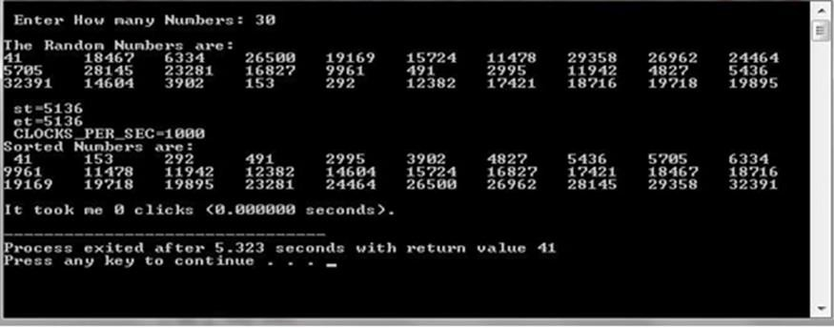

**LAB VIVA QUESTIONS:**

1. What is the average case time complexity of quick sort.
2. Explain is divide and conquer.
3. Define in place sorting algorithm.
4. List different ways of selecting pivot element.

### PROGRAM 2: MERGE SORT.

**AIM:** Implement merge sort algorithm to sort a given set of elements and determine the time required to sort the elements. Repeat the experiment for different values of n, the number of elements in the list to be sorted and plot a graph of the time taken versus n. The elements can be read from a file or can be generated using the random number generator.

### RESOURCES:

Dev C++.

### PROGRAM LOGIC:

Merge Sort is a Divide and Conquer algorithm. It divides input array in two halves, calls itself for the two halves and then merges the two sorted halves.

The merge() function is used for merging two halves. The merge(a, low, mid, high) is key process that assumes that a[low..mid] and a[mid+1..high] are sorted and merges the two sorted sub- arrays into one.

### PROCEDURE:

1. Create: Open Dev C++, write a program after that save the program with .c extension.
2. Compile: Alt + F9.
3. Execute: Ctrl + F10.

### SOURCE CODE:

#include <stdio.h> #include<time.h> int b[50000];

void Merge(int a[], int low, int mid, int high)

{

int i, j, k;

i=low; j=mid+1; k=low; while ( i<=mid && j<=high )

{

if( a[i] <= a[j] )

b[k++] = a[i++] ;

else

b[k++] = a[j++] ;

}

while (i<=mid)

b[k++] = a[i++] ;

while (j<=high)

b[k++] = a[j++] ;

for(k=low; k<=high; k++) a[k] = b[k];

}

voidMergeSort(int a[], int low, int high)

{

int mid;

if(low >= high)

return;

mid = (low+high)/2 ; MergeSort(a, low, mid); MergeSort(a, mid+1, high); Merge(a, low, mid, high);

}

void main()

{

int n, a[50000],k; clock_tst,et; doublets;

printf("\n Enter How many Numbers:"); scanf("%d", &n);

printf("\nThe Random Numbers are:\n"); for(k=1; k<=n; k++)

{

a[k]=rand(); printf("%d\t", a[k]);

}

st=clock(); MergeSort(a, 1, n); et=clock();

ts=(double)(et-st)/CLOCKS_PER_SEC;

printf("\n Sorted Numbers are : \n "); for(k=1; k<=n; k++)

printf("%d\t", a[k]); printf("\nThe time taken is %e",ts);

}

### INPUT/ OUTPUT

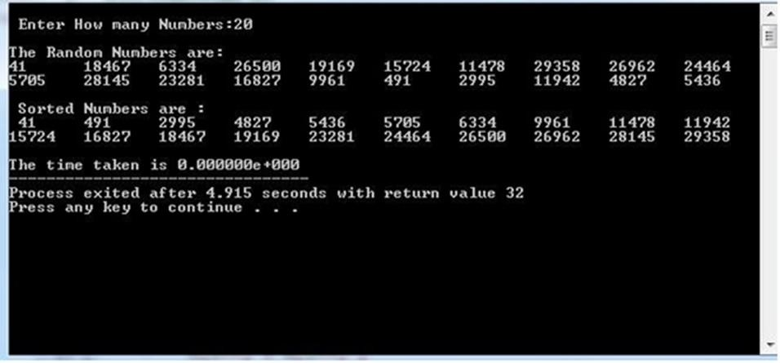

**LAB VIVA QUESTIONS:**

1. What is the running time of merge sort?
2. What technique is used to sort elements in merge sort?
3. Is merge sort in place sorting algorithm?
4. Define stable sort algorithm.

### PROGRAM 3: WARSHALL’S ALGORITHM. AIM:

1. Obtain the Topological ordering of vertices in a given digraph.

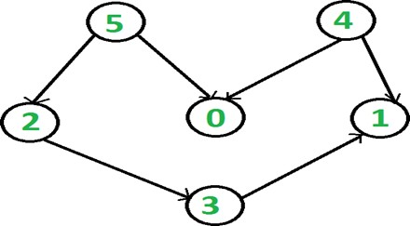

1. Compute the transitive closure of a given directed graph using Warshall's algorithm.

### RESOURCES:

Dev C++.

### PROGRAM LOGIC:

**Topological Ordering:**

In topological sorting, a temporary stack is used with the name “s”. The node number is not printed immediately; first iteratively call topological sorting for all its adjacent vertices, then push adjacent vertex to stack. Finally, print contents of stack. Note that a vertex is pushed to stack only when all of its adjacent vertices (and their adjacent vertices and so on) are already in stack.

### Transitive Closure:

Given a directed graph, find out if a vertex j is reachable from another vertex i for all vertex pairs (i, j) in the given graph. Here reachable mean that there is a path from vertex i to j. The reach- ability matrix is called transitive closure of a graph.

### PROCEDURE:

1. Create: Open Dev C++, write a program after that save the program with .c extension.
2. Compile: Alt + F9.
3. Execute: Ctrl + F10.

### SOURCE CODE: (a)

// Topological ordering #include<stdio.h>

int a[10][10],n,indegre[10]; voidfind_indegre ()

{

intj,i,sum; for(j=0;j<n;j++)

{

sum=0; for(i=0;i<n;i++)

sum+=a[i][j]; indegre[j]=sum;

}

}

void topology()

{

inti,u,v,t[10],s[10],top=-1,k=0; find_indegre(); for(i=0;i<n;i++)

{

if(indegre[i]==0)

s[++top]=i;

}

while(top!=-1)

{

u=s[top--];

t[k++]=u; //top element of stack is stored in temporary array for(v=0;v<n;v++)

{

if(a[u][v]==1)

{

indegre[v]--; if(indegre[v]==0)

s[++top]=v; //Pushing adjacent vertex to stack

}

}

}

printf ("The topological Sequence is:\n"); for(i=0;i<n;i++)

printf ("%d ",t[i]);

}

void main()

{

inti,j;

printf("Enter number of jobs:"); scanf("%d",&n);

printf("\nEnter the adjacency matrix:\n"); for(i=0;i<n;i++)

{

for(j=0;j<n;j++)

scanf("%d",&a[i][j]);

}

topology();

}

### INPUT/ OUTPUT:

**Topological ordering:**

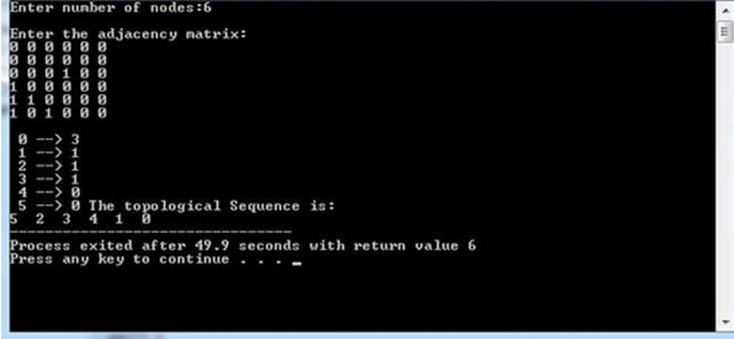

### SOURCE CODE: (b)

//Transitive closure of a graph using Warshall's algorithm #include <stdio.h>

intn,a[10][10],p[10][10];

void path()

{

inti,j,k; for(i=0;i<n;i++)

for(j=0;j<n;j++)

p[i][j]=a[i][j]; for(k=0;k<n;k++)

for(i=0;i<n;i++)

for(j=0;j<n;j++)

if(p[i][k]==1&&p[k][j]==1) p[i][j]=1;

}

void main()

{

inti,j;

printf("Enter the number of nodes:"); scanf("%d",&n);

printf("\nEnter the adjacency matrix:\n"); for(i=0;i<n;i++)

for(j=0;j<n;j++)

scanf("%d",&a[i][j]);

path();

printf("\nThe path matrix is shown below\n"); for(i=0;i<n;i++)

{

for(j=0;j<n;j++)

printf("%d ",p[i][j]); printf("\n");

}

}

### INPUT/ OUTPUT:

**Transitive closure of a graph using Warshall's algorithm:**

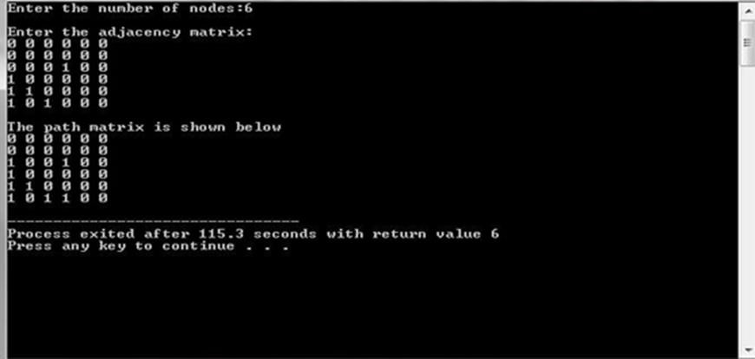

### LAB VIVA QUESTIONS:

1. Define transitive closure.
2. Define topological sequence.
3. What is the time complexity of Warshall's algorithm?

### PROGRAM 4: KNAPSACK PROBLEM.

**AIM:** Implement 0/1 Knapsack problem using Dynamic Programming.

### RESOURCES:

Dev C++.

### PROGRAM LOGIC:

Given some items, pack the knapsack to get the maximum total profit. Each item has some Weight and some profit. Total weight that we can carry is no more than some fixed number W.

### PROCEDURE:

1. Create: Open Dev C++, write a program after that save the program with .c extension.
2. Compile: Alt + F9.
3. Execute: Ctrl + F10.

### SOURCE CODE:

#include<stdio.h>

int w[10],p[10],v[10][10],n,i,j,cap,x[10]={0};

int max(inti,int j)

{

return ((i>j)?i:j);

}

int knap(inti,int j)

{

int value; if(v[i][j]<0)

{

if(j<w[i])

value=knap(i-1,j);

else

value=max(knap(i-1,j),p[i]+knap(i-1,j-w[i]));

v[i][j]=value;

}

return(v[i][j]);

}

int main()

{

intprofit,count=0;

printf("\nEnter the number of objects "); scanf("%d",&n);

printf("Enter the profit and weights of the elements \n "); for(i=1;i<=n;i++)

{

printf("\nEnter profit and weight For object no %d :",i); scanf("%d%d",&p[i],&w[i]);

}

printf("\nEnter the capacity "); scanf("%d",&cap); for(i=0;i<=n;i++)

for(j=0;j<=cap;j++)

if((i==0)||(j==0))

v[i][j]=0;

else

i=n; j=cap;

profit=knap(n,cap);

while(j!=0&&i!=0)

{

v[i][j]=-1;

if(v[i][j]!=v[i-1][j])

{

else

}

}

i--;

x[i]=1;

j=j-w[i];

i--;

printf("object included are \n "); printf("Sl.no\tweight\tprofit\n");

for(i=1;i<=n;i++)

if(x[i])

printf("%d\t%d\t%d\n",++count,w[i],p[i]); printf("Total profit = %d\n",profit);

}

### INPUT / OUTPUT:

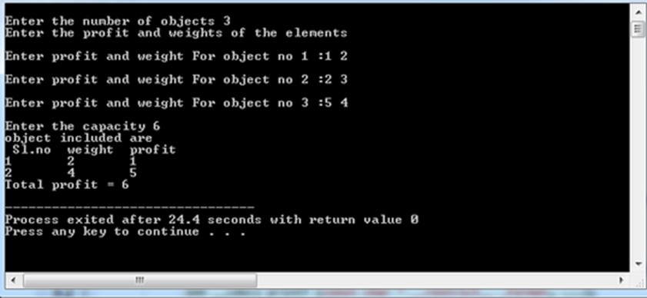

**LAB VIVA QUESTIONS:**

1. Define knapsack problem.
2. Define principle of optimality.
3. What is the optimal solution for knapsack problem?
4. What is the time complexity of knapsack problem?

### PROGRAM 5: SHORTEST PATHS ALGORITHM.

**AIM:** From a given vertex in a weighted connected graph, find shortest paths to other vertices using Dijkstra’s algorithm.

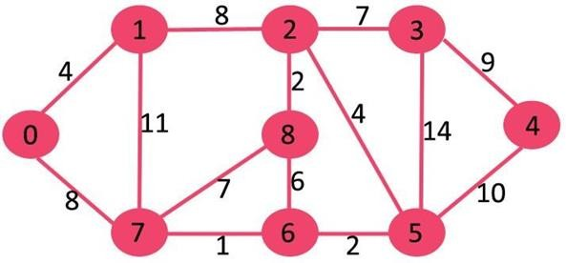

### RESOURCES:

Dev C++.

### PROGRAM LOGIC:

1. Create a set S that keeps track of vertices included in shortest path tree, i.e., whose minimum distance from source is calculated and finalized. Initially, this set is

empty.

1. Assign a distance value to all vertices in the input graph. Initialize all distance values as INFINITE. Assign distance value as 0 for the source vertex so that it is picked first.
2. While S doesn’t include all vertices.
   1. Pick a vertex u which is not there in S and has minimum distance value.
   2. Include u to S.
   3. Update distance value of all adjacent vertices of u.

To update the distance values, iterate through all adjacent vertices. For every adjacent vertex v, if sum of distance value of u (from source) and weight of edge u-v, is less than the distance value of v, then update the distance value of v.

### PROCEDURE:

1. Create: Open Dev C++, write a program after that save the program with .c extension.
2. Compile: Alt + F9.
3. Execute: Ctrl + F10.

### SOURCE CODE:

#include<stdio.h> #define infinity 999

void dij(int n, int v,int cost[20][20], int dist[])

{

int i,u,count,w,flag[20],min; for(i=1;i<=n;i++)

flag[i]=0, dist[i]=cost[v][i]; count=2;

while(count<=n)

{

min=99; for(w=1;w<=n;w++)

if(dist[w]<min && !flag[w])

{

min=dist[w]; u=w;

}

flag[u]=1; count++;

for(w=1;w<=n;w++)

if((dist[u]+cost[u][w]<dist[w]) && !flag[w]) dist[w]=dist[u]+cost[u][w];

}

}

int main()

{

int n,v,i,j,cost[20][20],dist[20]; printf("enter the number of nodes:"); scanf("%d",&n);

printf("\n enter the cost matrix:\n"); for(i=1;i<=n;i++)

for(j=1;j<=n;j++)

{

scanf("%d",&cost[i][j]);

if(cost[i][j] == 0)

cost[i][j]=infinity;

}

printf("\n enter the source matrix:"); scanf("%d",&v);

dij(n,v,cost,dist);

printf("\n shortest path : \n"); for(i=1;i<=n;i++)

if(i!=v)

printf("%d->%d,cost=%d\n",v,i,dist[i]);

}

### INPUT / OUTPUT:

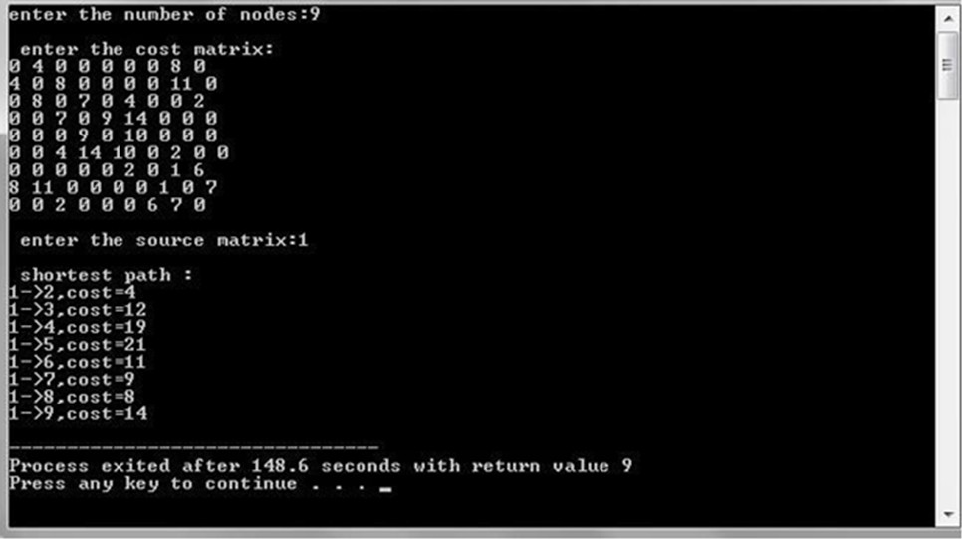

**LAB VIVA QUESTIONS:**

1. What is the time complexity of Dijkstra’s algorithm?
2. Define cost matrix.
3. Define directed graph.
4. Define connected graph.

### PROGRAM 6: MINIMUM COST SPANNING TREE.

**AIM:** Find Minimum Cost Spanning Tree of a given undirected graph using Kruskal’s algorithm.

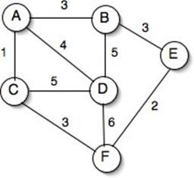

### RESOURCES:

Dev C++.

### PROGRAM LOGIC:

1. Sort all the edges in non-decreasing order of their weight.
2. Pick the smallest edge. Check if it forms a cycle with the spanning tree formed so far. If cycle is not formed, include this edge. Else, discard it.
3. Repeat step#2 until there are (V-1) edges in the spanning tree.

### PROCEDURE:

1. Create: Open Dev C++, write a program after that save the program with .c extension..
2. Compile: Alt + F9.
3. Execute: Ctrl + F10.

### SOURCE CODE:

#include<stdio.h> #include<stdlib.h> inti,j,k,a,b,u,v,n,ne=1;

intmin,mincost=0,cost[9][9],parent[9]; int find(int);

intuni(int,int); void main()

{

printf("\n Implementation of Kruskal's algorithm\n\n"); printf("\nEnter the no. of vertices\n");

scanf("%d",&n);

printf("\nEnter the cost adjacency matrix\n"); for(i=1;i<=n;i++)

{

for(j=1;j<=n;j++)

{

scanf("%d",&cost[i][j]); if(cost[i][j]==0)

cost[i][j]=999;

}

}

printf("\nThe edges of Minimum Cost Spanning Tree are\n\n"); while(ne<n)

{

for(i=1,min=999;i<=n;i++)

{

for(j=1;j<=n;j++)

{

if(cost[i][j]<min)

{

min=cost[i][j]; a=u=i;

b=v=j;

}

}

}

u=find(u); v=find(v); if(uni(u,v))

{

printf("\n%d edge (%d,%d) =%d\n",ne++,a,b,min); mincost +=min;

}

cost[a][b]=cost[b][a]=999;

}

printf("\n\tMinimum cost = %d\n",mincost);

}

int find(int i)

{

while(parent[i])

i=parent[i]; return i;

}

intuni(inti,int j)

{

if(i!=j)

{

}

parent[j]=i; return 1;

return 0;

}

### INPUT/ OUTPUT:

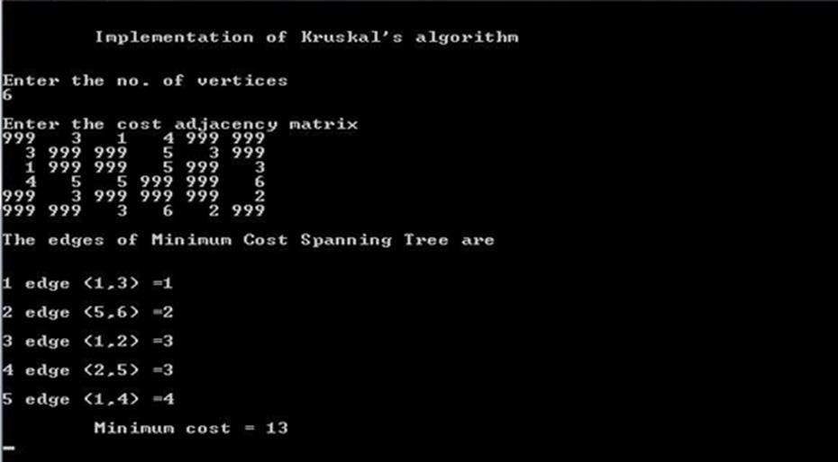

**LAB VIVA QUESTIONS:**

1. What is the time complexity of Kruskal’s algorithm.
2. Define spanning tree.
3. Define minimum cost spanning tree.

### PROGRAM 7: TREE TRAVESRSALS.

**AIM:** Perform various tree traversal algorithms for a given tree.

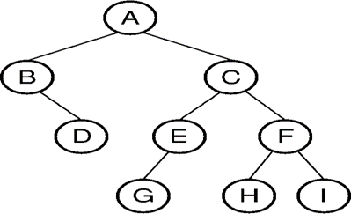

### RESOURCES:

Dev C++.

### PROGRAM LOGIC:

Traversal is a process to visit all the nodes of a tree and may print their values too.

### Inorder(tree).

* 1. Traverse the left subtree, i.e., call Inorder(left-subtree).
  2. Visit the root.
  3. Traverse the right subtree, i.e., call Inorder(right-subtree).

### Postorder(tree)

1. Traverse the left subtree, i.e., call Postorder(left-subtree).
2. Traverse the right subtree, i.e., call Postorder(right-subtree).
3. Visit the root.

### Preorder(tree)

1. Visit the root.
2. Traverse the left subtree, i.e., call Preorder(left-subtree).
3. Traverse the right subtree, i.e., call Preorder(right-subtree).

### PROCEDURE:

1. Create: Open Dev C++, write a program after that save the program with .c extension.
2. Compile: Alt + F9.
3. Execute: Ctrl + F10.

### SOURCE CODE:

#include<stdio.h> #include<stdlib.h> typedefstructtreeNode

{

int data;

structtreeNode *left; structtreeNode *right;

}treeNode;

treeNode* FindMin(treeNode *node)

{

if(node==NULL)

{

/* There is no element in the tree */ return NULL;

}

if(node->left) /* Go to the left sub tree to find the min element */ returnFindMin(node->left);

else

}

return node;

treeNode * insert(treeNode *node,int data)

{

if(node==NULL)

{

treeNode *temp;

temp = (treeNode *)malloc(sizeof(treeNode)); temp -> data = data;

temp -> left = temp -> right = NULL; return temp;

` }

if(data >(node->data))

{

node->right = insert(node->right,data);

}

else if(data < (node->data))

{

node->left = insert(node->left,data);

}

/* Else there is nothing to do as the data is already in the tree. */ return node;

}

treeNode * deletion(treeNode *node, int data)

{

treeNode *temp; if(node==NULL)

{

printf("Element Not Found");

}

else if(data < node->data)

{

node->left = deletion(node->left, data);

}

else if(data > node->data)

{

}

Else

{

node->right = deletion(node->right, data);

/* Now We can delete this node and replace with either minimum elementin the right

sub tree or maximum element in the left subtree */ if(node->right && node->left)

{

}

else

{

/* Here we will replace with minimum element in the right sub tree */ temp = FindMin(node->right);

node -> data = temp->data;

/* As we replaced it with some other node, we have to delete that node */ node -> right = deletion(node->right,temp->data);

/* If there is only one or zero children then we can directlyremove it from the tree and connect its parent to its child */

temp = node;

if(node->left == NULL)

node = node->right; else if(node->right == NULL)

node = node->left;

free(temp); /* temp is longer required */

}

}

return node;

}

treeNode * search(treeNode *node, int data)

{

if(node==NULL)

{

/* Element is not found */ return NULL;

}

if(data > node->data)

{

/* Search in the right sub tree. */ return search(node->right,data);

}

else if(data < node->data)

{

}

else

{

}

}

/* Search in the left sub tree. */ return search(node->left,data);

/* Element Found */ return node;

voidinorder(treeNode *node)

{

if(node!=NULL)

{

}

else

}

inorder(node->left); printf("%d ",node->data); inorder(node->right);

return;

void preorder(treeNode *node)

{

if(node!=NULL)

{

}

else

}

printf("%d ",node->data); preorder(node->left); preorder(node->right);

return;

Voidpostorder(treeNode *node)

{

if(node!=NULL)

{

}

else

}

postorder(node->left); postorder(node->right); printf("%d ",node->data);

return;

void main()

{

treeNode *t,*root = NULL; intch, elt;

do

{

printf("\n ### Binary Search Tree Operations ###"); printf("\n Press 1-Creation of BST");

printf("\n 2-deleting "); printf("\n 3-searching ");

printf("\n 4-Traverse in Inorder"); printf("\n 5-Traverse in Preorder"); printf("\n 6-Traverse in Postorder"); printf("\n 7-Exit\n");

printf("\n enter yor choice "); scanf("%d", &ch);

switch (ch)

{

case 1: printf("enter element to be inserted"); scanf("%d", &elt);

root = insert(root, elt); break;

case 2: printf("enter element to be deleted");

scanf("%d",&elt); deletion(root,elt); break;

case 3: printf("enter element to be search");

scanf("%d",&elt); t=search(root,elt); if(t==NULL)

printf("element NOT found"); break;

case 4: printf("\n BST Traversal in INORDER \n"); inorder(root);

break;

case 5: printf("\n BST Traversal in PREORDER \n"); preorder(root);

break;

case 6: printf("\n BST Traversal in POSTORDER \n"); postorder(root);

break;

case 7: printf("\n\n Terminating \n\n");

break;

default: printf("\n\nInvalid Option !!! Try Again !! \n\n"); break;

}

} while (ch!= 7);

}

### INPUT / OUTPUT:

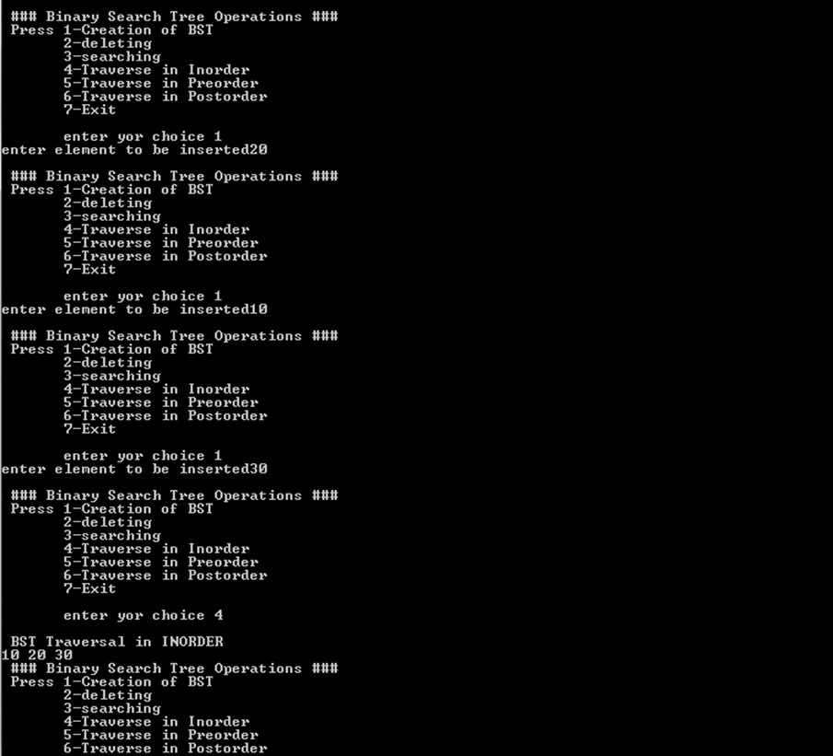

**LAB VIVA QUESTIONS:**

1. Define binary tree.
2. List different tree traversals.
3. Explain inorder travels with example.
4. Explain preorder travels with example.
5. Explain postorder travels with example.

### PROGRAM 8: GRAPH TRAVERSALS AIM:

1. Print all the nodes reachable from a given starting node in a digraph using BFS method.

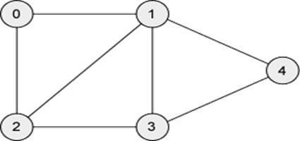

1. Check whether a given graph is connected or not using DFS method.

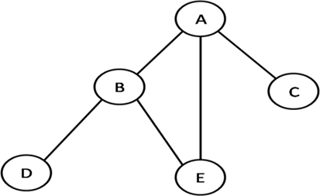

### RESOURCES:

Dev C++.

### PROGRAM LOGIC:

**Breadth first traversal**

Breadth First Search (BFS) algorithm traverses a graph in a breadth ward motion and uses a queue to remember to get the next vertex to start a search.

1. Visit the adjacent unvisited vertex. Mark it as visited. Display it. Insert it in a queue.
2. If no adjacent vertex is found, remove the first vertex from the queue.
3. Repeat Rule 1 and Rule 2 until the queue is empty.

### Depth first traversal

Depth First Search (DFS) algorithm traverses a graph in a depth ward motion and uses a stack to remember to get the next vertex to start a search.

1. Visit the adjacent unvisited vertex. Mark it as visited. Display it. Push it in a stack.
2. If no adjacent vertex is found, pop up a vertex from the stack. (It will pop up all the vertices from the stack, which do not have adjacent vertices.).
3. Repeat Rule 1 and Rule 2 until the stack is empty.

### PROCEDURE:

1. Create: Open Dev C++, write a program after that save the program with .c extension.
2. Compile: Alt + F9.
3. Execute: Ctrl + F10.

### SOURCE CODE:

//Breadth first traversal #include<stdio.h> #include<conio.h>

int a[20][20],q[20],visited[20],n,i,j,f=-1,r=0; voidbfs(int v)

{

q[++r]=v; visited[v]=1; while(f<=r)

{

for(i=1;i<=n;i++)

if(a[v][i] && !visited[i])

{

} f++;

v=q[f];

}

}

visited[i]=1; q[++r]=i;

void main()

{

int v;

printf("\n Enter the number of vertices:"); scanf("%d",&n);

for(i=1;i<=n;i++)

{

q[i]=0;

visited[i]=0;

}

printf("\n Enter graph data in matrix form:\n"); for(i=1;i<=n;i++)

for(j=1;j<=n;j++)

scanf("%d",&a[i][j]); printf("\n Enter the starting vertex:"); scanf("%d",&v);

bfs(v);

printf("\n The node which are reachable are:\n"); for(i=1;i<=n;i++)

if(visited[i])

printf("%d\t",q[i]);

else

}

printf("\n Bfs is not possible");

//Checking whether a given graph is connected or not using DFS method #include<stdio.h>

#include<conio.h>

int a[20][20],reach[20],n; void dfs(int v)

{

int i; reach[v]=1; for(i=1;i<=n;i++)

if(a[v][i] && !reach[i])

{

}

}

void main()

{

printf("\n %d->%d",v,i); dfs(i);

int i,j,count=0;

printf("\n Enter number of vertices:"); scanf("%d",&n);

for(i=1;i<=n;i++)

{

reach[i]=0; for(j=1;j<=n;j++)

a[i][j]=0;

}

printf("\n Enter the adjacency matrix:\n"); for(i=1;i<=n;i++)

for(j=1;j<=n;j++)

scanf("%d",&a[i][j]);

dfs(1); printf("\n"); for(i=1;i<=n;i++){

if(reach[i])

count++;

}

if(count==n)

printf("\n Graph is connected");

else

}

printf("\n Graph is not connected");

### INPUT / OUTPUT:

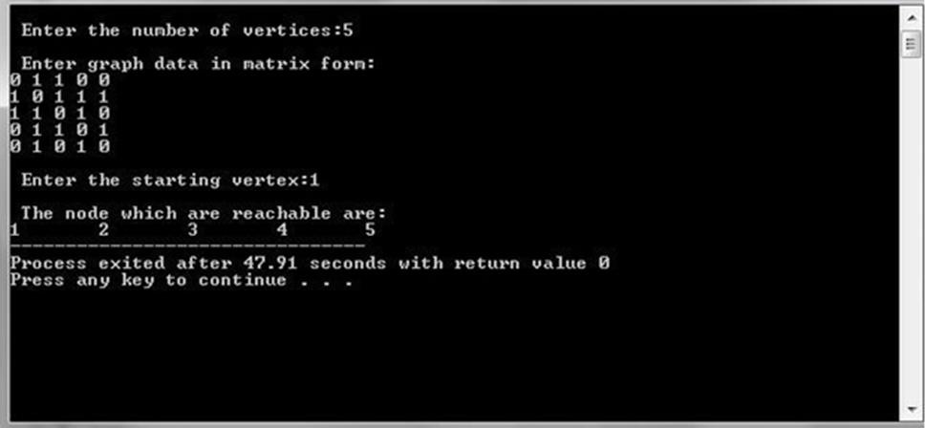**Breadth first traversal**

### Checking whether a given graph is connected or not using DFS method

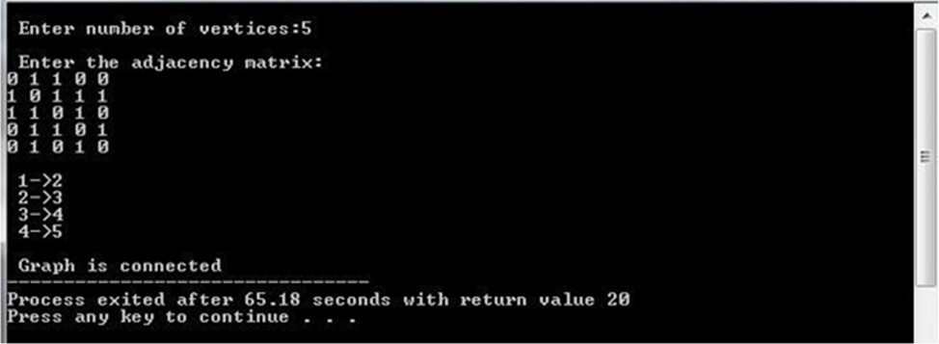

**LAB VIVA QUESTIONS:**

1. Define graph, connected graph.
2. List the different graph traversals.
3. Explain DFS traversal.
4. Explain BFS traversal.
5. What are the time complexities of BFS and DFS algorithms?

### PROGRAM 9: SUM OF SUB SETS PROBLEM.

**AIM:** Find a subset of a given set S = {sl, s2. sn} of n positive integers whose sum is equal to a

given positive integer d. For example, if S= {1, 2, 5, 6, 8} and d = 9 there are two solutions {1, 2, 6} and {1, 8}.A suitable message is to be displayed if the given problem instance doesn't have a solution.

### RESOURCES:

Dev C++.

### PROGRAM LOGIC:

Given a set of non-negative integers, and a value sum, determine if there is a subset of the given set with sum equal to given sum.

### PROCEDURE:

1. Create: Open Dev C++, write a program after that save the program with .c extension.
2. Compile: Alt + F9.
3. Execute: Ctrl + F10.

### SOURCE CODE:

#include<stdio.h> #define TRUE 1

#define FALSE 0

int inc[50],w[50],sum,n; voidsumset(int ,int ,int);

int promising(inti,intwt,int total)

{

return (((wt+total)>=sum)&&((wt==sum)||(wt+w[i+1]<=sum)));

}

void main()

{

inti,j,n,temp,total=0;

printf("\n Enter how many numbers: "); scanf("%d",&n);

printf("\n Enter %d numbers : ",n); for (i=0;i<n;i++)

{

scanf("%d",&w[i]); total+=w[i];

}

printf("\n Input the sum value to create sub set: "); scanf("%d",&sum);

for (i=0;i<=n;i++)

for (j=0;j<n-1;j++)

if(w[j]>w[j+1])

{

temp=w[j]; w[j]=w[j+1]; w[j+1]=temp;

}

printf("\n The given %d numbers in ascending order: ",n); for (i=0;i<n;i++)

printf("%3d",w[i]); if((total<sum))

printf("\n Subset construction is not possible");

else

{

}

}

for (i=0;i<n;i++)

inc[i]=0;

printf("\n The solution using backtracking is:\n"); sumset(-1,0,total);

voidsumset(inti,intwt,int total)

{

int j; if(promising(i,wt,total))

{

if(wt==sum)

{

printf("\n{");

for (j=0;j<=i;j++)

}

else

{

}

}

### }

if(inc[j])

printf("%3d",w[j]);

printf(" }\n");

inc[i+1]=TRUE;

sumset(i+1,wt+w[i+1],total-w[i+1]); inc[i+1]=FALSE;

sumset(i+1,wt,total-w[i+1]);

### INPUT / OUTPUT:

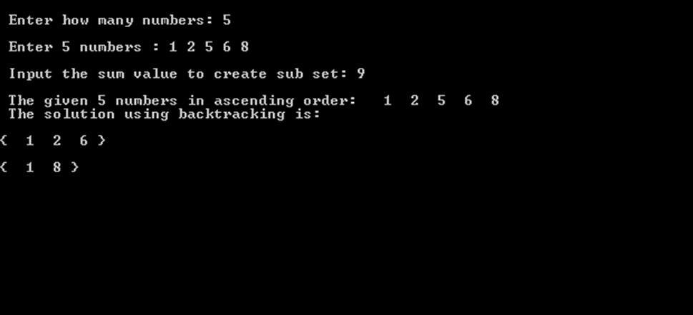

**LAB VIVA QUESTIONS:**

1. Define is Back – Tracking.
2. Explain Sum of subset problem.
3. What is time complexity of sum of subset problem?

### PROGRAM 10: TRAVELLING SALES PERSON PROBLEM.

**AIM:** Implement any scheme to find the optimal solution for the Traveling Sales Person problem and then solve the same problem instance using any approximation algorithm and determine the error in the approximation

### RESOURCES:

**Dev C++.**

### PROGRAM LOGIC:

1. Check for the disconnection between the current city and the next city.
2. Check whether the travelling sales person has visited all the cities.
3. Find the next city to be visited.
4. Find the solution and terminate.

### PROCEDURE:

1. Create: Open Dev C++, write a program after that save the program with .c extension.
2. Compile: Alt + F9.
3. Execute: Ctrl + F10.

### SOURCE CODE:

#include<stdio.h> ints,c[100][100],ver; float optimum=999,sum;

/* function to swap array elements */ void swap(int v[], int i, int j)

{

int t;

t = v[i]; v[i] = v[j]; v[j] = t;

}

/* recursive function to generate permutations */ voidbrute_force(int v[], int n, int i)

{

// this function generates the permutations of the array from element i to element n – 1. int j,sum1,k;

//if we are at the end of the array, we have one permutation if (i == n)

{

if(v[0]==s)

{

for (j=0; j<n; j++)

printf ("%d ", v[j]); sum1=0;

for( k=0;k<n-1;k++)

{

sum1=sum1+c[v[k]][v[k+1]];

}

}

}

else

sum1=sum1+c[v[n-1]][s]; printf("sum = %d\n",sum1); if (sum1<optimum)

optimum=sum1;

// recursively explore the permutations starting at index i going through index n – 1*/ for (j=i; j<n; j++)

{

/* try the array with i and j switched */ swap (v, i, j);

brute_force (v, n, i+1);

/* swap them back the way they were */ swap (v, i, j);

}

}

voidnearest_neighbour(intver)

{

intmin,p,i,j,vis[20],from; for(i=1;i<=ver;i++)

vis[i]=0;

vis[s]=1; from=s; sum=0;

for(j=1;j<ver;j++)

{

min=999; for(i=1;i<=ver;i++)

if(vis[i] !=1 &&c[from][i]<min && c[from][i] !=0 )

{

min= c[from][i]; p=i;

}

vis[p]=1; from=p; sum=sum+min;

}

sum=sum+c[from][s];

}

void main ()

{

intver,v[100],i,j;

printf("Enter n : ");

scanf("%d",&ver); for (i=0; i<ver; i++)

v[i] = i+1; printf("Enter cost matrix\n"); for(i=1;i<=ver;i++)

for(j=1;j<=ver;j++)

scanf("%d",&c[i][j]); printf("\nEnter source : "); scanf("%d",&s);

brute_force (v, ver, 0);

printf("\nOptimum solution with brute force technique is=%f\n",optimum); nearest_neighbour(ver);

printf("\nSolution with nearest neighbour technique is=%f\n",sum); printf("The approximation val is=%f",((sum/optimum)-1)*100); printf(" % ");

}

### INPUT / OUTPUT:

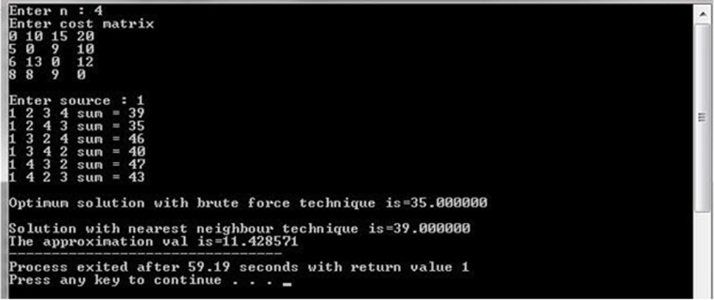

**LAB VIVA QUESTIONS:**

1. Define Optimal Solution.
2. Explain Travelling Sales Person Problem.
3. What is the time complexity of Travelling Sales Person Problem?

### PROGRAM 11: MINIMUM COST SPANNING TREE.

**AIM:** Find Minimum Cost Spanning Tree of a given undirected graph using Prim’s algorithm.

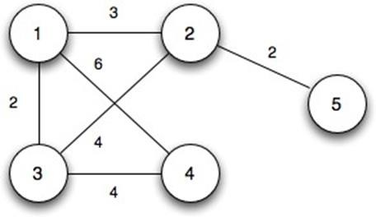

### RESOURCES:

Dev C++.

### PROGRAM LOGIC:

1. Create a set Sthat keeps track of vertices already included in MST.
2. Assign a key value to all vertices in the input graph. Initialize all key values as INFINITE. Assign key value as 0 for the first vertex so that it is picked first.
3. While S doesn’t include all vertices.
   1. Pick a vertex u which is not there in Sand has minimum key value.
   2. Include u to S.
   3. Update key value of all adjacent vertices of u.

To update the key values, iterate through all adjacent vertices. For every adjacent vertex v, if weight of edge u – v is less than the previous key value of v, update the key value as weight of u – v.

The idea of using key values is to pick the minimum weight edge from cut. The key values are used only for vertices which are not yet included in MST, the key value for these vertices indicate the minimum weight edges connecting them to the set of vertices included in MST.

### PROCEDURE:

1. Create: Open Dev C++, write a program after that save the program with .c extension.
2. Compile: Alt + F9.
3. Execute: Ctrl + F10.

### SOURCE CODE.

#include<stdio.h> inta,b,u,v,n,i,j,ne=1;

int visited[10]={0},min,mincost=0,cost[10][10]; void main()

{

printf("\n Enter the number of nodes:"); scanf("%d",&n);

printf("\n Enter the adjacency matrix:\n"); for(i=1;i<=n;i++)

for(j=1;j<=n;j++)

{

scanf("%d",&cost[i][j]); if(cost[i][j]==0)

cost[i][j]=999;

}

visited[1]=1; printf("\n"); while(ne<n)

{

for(i=1,min=999;i<=n;i++) for(j=1;j<=n;j++)

if(cost[i][j]<min)

if(visited[i]!=0)

{

min=cost[i][j]; a=u=i;

b=v=j;

}

if(visited[u]==0 || visited[v]==0)

{

printf("\n Edge %d:(%d %d) cost:%d",ne++,a,b,min); mincost+=min;

visited[b]=1;

}

cost[a][b]=cost[b][a]=999;

}

printf("\n Minimun cost=%d",mincost);

}

### INPUT / OUTPUT:

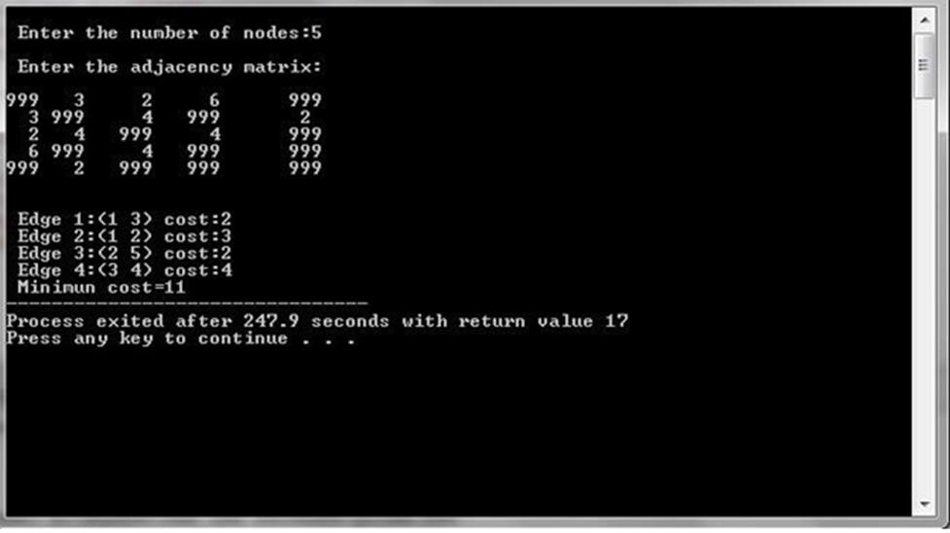

**LAB VIVA QUESTIONS:**

1. What is Minimum Cost spanning Tree.
2. Explain Prim’s ALGORITHM.
3. What is time complexity of Prim’s algorithm.

### PROGRAM 12: ALL PAIRS SHORTEST PATHS.

**AIM:** Implement All-Pairs Shortest Paths Problem using Floyd's algorithm.

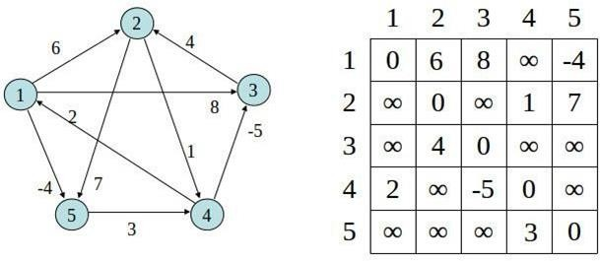

### RESOURCES:

**Dev C++.**

### PROGRAM LOGIC:

Initialize the solution matrix same as the input graph matrix as a first step. Then we update the solution matrix by considering all vertices as an intermediate vertex. The ideas is to one by one pick all vertices and update all shortest paths which include the picked vertex as an intermediate vertex in the shortest path.

When we pick vertex number k as an intermediate vertex, we already have considered vertices {0, 1, 2, .. k-1} as intermediate vertices.

For every pair (i, j) of source and destination vertices respectively, there are two possible

cases.

1. k is not an intermediate vertex in shortest path from i to j. We keep the value of dist[i][j] as it is.
2. k is an intermediate vertex in shortest path from i to j. We update the value of dist[i][j] as dist[i][k] + dist[k][j].

### PROCEDURE:

1. Create: Open Dev C++, write a program after that save the program with .c extension.
2. Compile: Alt + F9.
3. Execute: Ctrl + F10.

### SOURCE CODE.

#include<stdio.h> int min(int,int);

voidfloyds(int p[10][10],int n)

{

inti,j,k; for(k=1;k<=n;k++)

for(i=1;i<=n;i++)

for(j=1;j<=n;j++)

if(i==j)

}

int min(inta,int b)

{

else

p[i][j]=0; p[i][j]=min(p[i][j],p[i][k]+p[k][j]);

if(a<b) else

}

return(a); return(b);

void main()

{

int p[10][10],w,n,e,u,v,i,j;

printf("\n Enter the number of vertices:"); scanf("%d",&n);

printf("\n Enter the number of edges:\n"); scanf("%d",&e);

for(i=1;i<=n;i++)

{

for(j=1;j<=n;j++)

p[i][j]=999;

}

for(i=1;i<=e;i++)

{

printf("\n Enter the end vertices of edge%d with its weight \n",i); scanf("%d%d%d",&u,&v,&w);

p[u][v]=w;

}

printf("\n Matrix of input data:\n"); for(i=1;i<=n;i++)

{

for(j=1;j<=n;j++)

printf("%d \t",p[i][j]); printf("\n");

}

floyds(p,n);

printf("\n Transitive closure:\n"); for(i=1;i<=n;i++)

{

for(j=1;j<=n;j++)

printf("%d \t",p[i][j]); printf("\n");

}

printf("\n The shortest paths are:\n"); for(i=1;i<=n;i++) for(j=1;j<=n;j++)

{

if(i!=j)

}

}

printf("\n <%d,%d>=%d",i,j,p[i][j]);

### INPUT / OUTPUT:

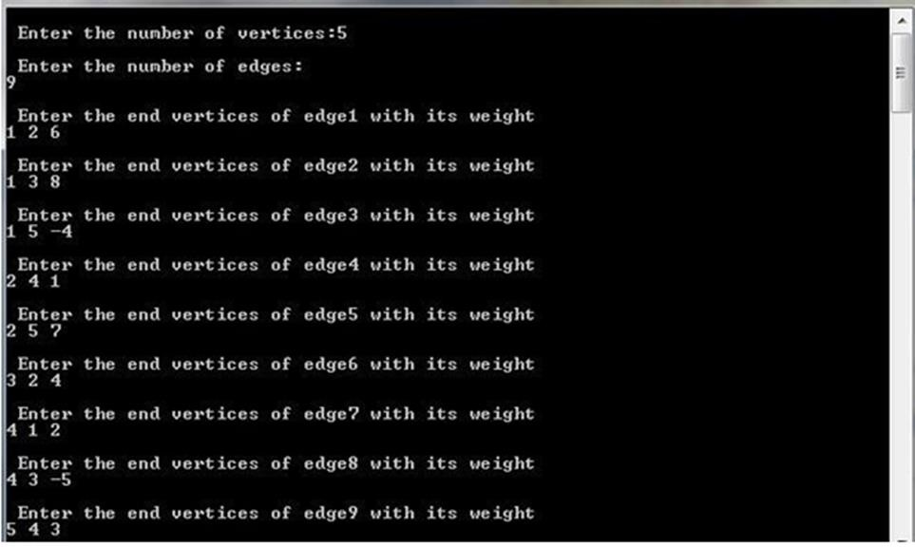

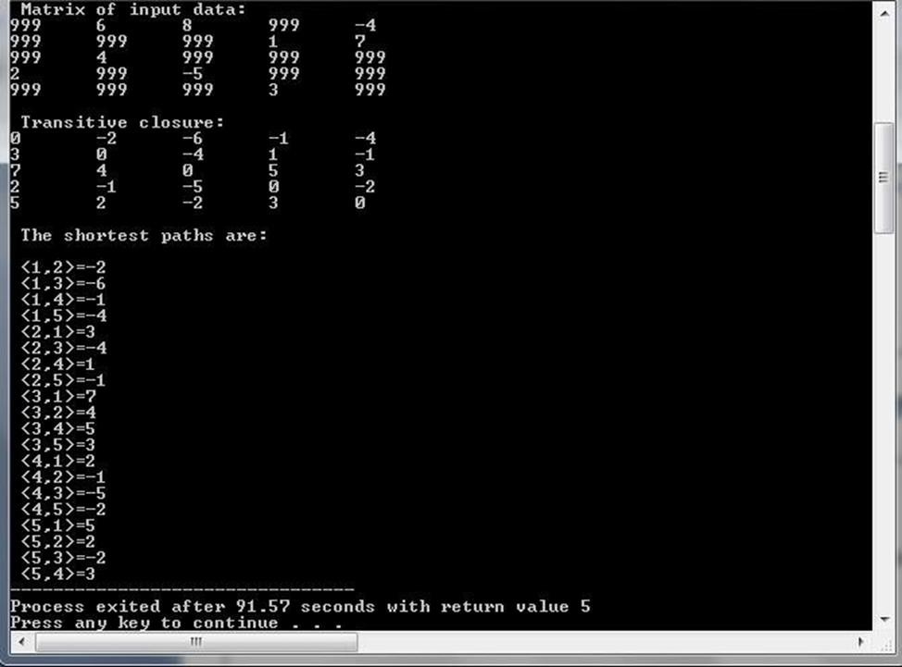

**LAB VIVA QUESTIONS:**

1. What is Floyd’s algorithm?
2. What is the time complexity of Floyd’s algorithm?
3. Define Distance Matrix.

### PROGRAM 13: N QUEENS PROBLEM.

**AIM:** Implement N Queen's problem using Back Tracking.

### RESOURCES:

Dev C++.

### PROGRAM LOGIC:

1. Start in the leftmost column.
2. If all queens are placed return true.
3. Try all rows in the current column. Do following for every tried row.
   1. If the queen can be placed safely in this row then mark this [row, column] as part of the solution and recursively check if placing queen here leads to a solution.
   2. If placing queen in [row, column] leads to a solution then return true.
   3. If placing queen doesn't lead to a solution then unmark this [row, column] (Backtrack) and go to step (a) to try other rows.
4. If all rows have been tried and nothing worked, return false to trigger Backtracking.

### PROCEDURE:

1. Create: Open Dev C++, write a program after that save the program with .c extension.
2. Compile: Alt + F9.
3. Execute: Ctrl + F10.

### SOURCE CODE:

#include<stdio.h> #include<math.h> int a[30],count=0; int place(intpos)

{

int i; for(i=1;i<pos;i++)

{

if((a[i]==a[pos])||((abs(a[i]-a[pos])==abs(i-pos)))) return 0;

}

return 1;

}

void print_sol(int n)

{

inti,j; count++;

printf("\n\nSolution #%d:\n",count); for(i=1;i<=n;i++)

{

for(j=1;j<=n;j++)

{

if(a[i]==j)

printf("Q\t");

else

}

printf("*\t");

printf("\n");

}

}

void queen(int n)

{

int k=1; a[k]=0;

while(k!=0)

{

a[k]=a[k]+1; while((a[k]<=n)&&!place(k))

a[k]++;

if(a[k]<=n)

{

if(k==n)

print_sol(n);

else

{

k++; a[k]=0;

}

else

}

}

}

k--;

void main()

{

inti,n;

printf("Enter the number of Queens\n"); scanf("%d",&n);

queen(n);

printf("\nTotal solutions=%d",count);

}

### INPUT / OUTPUT:

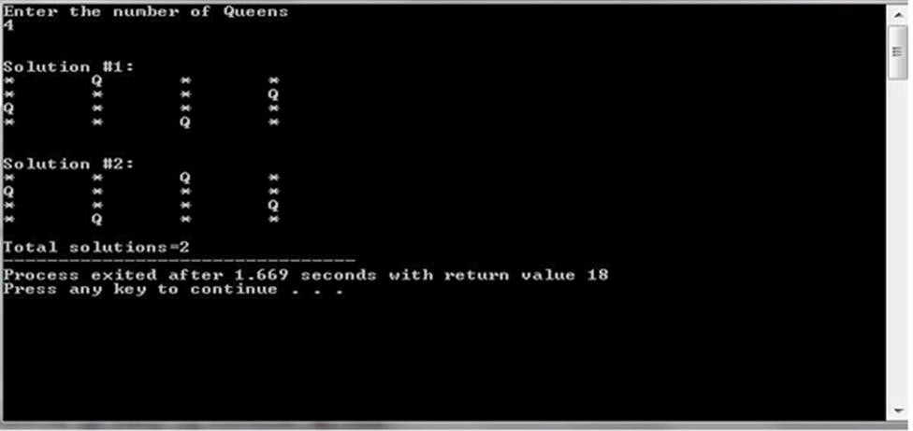

**LAB VIVA QUESTIONS:**

1. Define backtracking.
2. Define live node, dead node.
3. Define implicit and explicit constraints.
4. What is the time complexity of n – queens problem.

**ADDITIONAL PROGRAMS**

**PROGRAM 1: PATTERN MATCHING PROBLEM.**

**AIM:** Implement Naive Pattern Matching using Brute Force Technique.

### RESOURCES:

Dev C++.

### PROGRAM LOGIC:

**Input:** main string S, substring T.

**Output:** T's position in S.

1. Initialize the start position of the main string comparison index=0;
2. Set the starting coordinates of comparison i=0, j=0 in string S and string T;
3. Repeat the following operations until all characters of S or T are compared:
   1. If S[i]=T[j], continue to compare the next pair of characters of S and T.
   2. Otherwise, the starting position of the next match is index++, the main string backtracking index i=index, and the substring backtracking index j=0;
4. If all characters in T have been compared, the matching start index is returned; otherwise, 0 is returned;

### PROCEDURE:

1. Create: Open Dev C++, write a program after that save the program with .c extension.
2. Compile: Alt + F9.
3. Execute: Ctrl + F10.

### SOURCE CODE:

#include<stdio.h> #include<string.h>

void naive_string_matcher(char text[],char pat[])

{

char temp[100]; int n=strlen(text); int m=strlen(pat); int i,j,s,k,count=0; for(s=0;s<=n;s++)

{

for(j=s,k=0;j<m;j++,k++) temp[k]=text[s+k];

temp[k]='\0'; if(strcmp(pat,temp)==0)

{

} m++;

}

printf("\n Pattern Occurs With Shift : %d ",s); count++;

printf("\n\n No Of Times Pattern Occurs %d:",count);

}

int main()

{

char text[100],pat[100];

printf("\n ENTER THE TEXT : "); gets(text);

printf("\n ENTER THE PATTERN : ");

gets(pat); naive_string_matcher(text,pat); return 0;

}

### INPUT / OUTPUT:

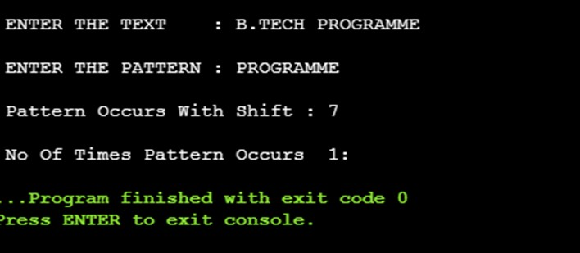

**PROGRAM 2: TOWER OF HANOI.**

**AIM:** Implement Tower’s of Hanoi using recursion.

### RESOURCES:

Dev C++.

### PROGRAM LOGIC:

Step 1 − Move n-1 disks from source to aux. Step 2 − Move nth disk from source to dest. Step 3 − Move n-1 disks from aux to dest.

### PROCEDURE:

1. Create: Open Dev C++, write a program after that save the program with .c extension.
2. Compile: Alt + F9.
3. Execute: Ctrl + F10.

### SOURCE CODE:

#include<stdio.h>

void towers(int, char, char, char); int main()

{

int num;

printf ("Enter the number of disks : "); scanf ("%d", &num);

printf ("The sequence of moves involved in the Tower of Hanoi are :\n"); towers (num, 'A', 'C', 'B');

return 0;

}

void towers( int num, char frompeg, char topeg, char auxpeg)

{

if (num == 1)

{

printf ("\n Move disk 1 from peg %c to peg %c", frompeg, topeg); return;

}

towers (num - 1, frompeg, auxpeg, topeg);

printf ("\n Move disk %d from peg %c to peg %c", num, frompeg, topeg); towers (num - 1, auxpeg, topeg, frompeg);

}

### INPUT / OUTPUT:

